# Table of Contents

1. **Abstract 5**
2. **Introduction 6**
3. **Definitions and Acronyms 6**
4. **Proposed system 6**
5. **Feasibility report 7** 
   1. General requirement feasibility report 7
   2. Problem in the current system 7
6. **Technical feasibility 7**
7. **Technical description 8**
8. **Graphical user interface 8**
9. **Project Design Description 8** 
   1. Purpose 8
   2. Scope 8
10. **Functional requirements 9**
11. **Performance requirements 9**
12. **Scope of the development project** 
    1. Database tier 9
    2. User tier 9
    3. Database connectivity tier 9
13. **Software requirement specification 10** 
    1. Requirement hardware 10
    2. Requirement software 10
14. **Modules description 10** 
    1. Accommodation information 10
    2. Booking module 11
    3. Facilities module 11
15. **Number of views 11** 
    1. Administrative view 11
16. **Performance requirements 12**
17. **User interface design 13**
18. **Dataflow diagrams 14**
19. **E-R-Diagrams 15**
20. **Unified modelling language diagram 16**
21. **Testing 19**
22. **Installation and project description 20**
23. **Screenshots of project 20**
24. **Conclusions and recommendations 24**
25. **References 25**

* + 1. **Abstract**

The system aims at the maintenance and management Hotel. It mainly takes care of the Hotel management at the core area of the database. The only Admin can visit the site and register with the required information that is expected by the system. Each registered guest can raise a request for the unit bookings. The Guests can scheduled with the information of the availability of the Rooms for they have requested the time.

The total front end was JAVA. The communicating client was designed using servlet . At all proper levels high care was taken to check that the system manages the date consistency with proper business validations. The database connectivity was planned using the Java Data Base Connectivity , the authorization was cross checked at all stages. The user level accessibility has been restricted into one zones the administrative .

* + 1. **Introduction**

The entire project has been developed keeping in view of the Distributed client server computing technology in mind. The specification have been normalized up to 3NF to eliminate all the anomalies that may arise due to the database transactions that are executed by the actual administration and users. The user interfaces are browser specific to give distributed accessibility for the overall system. The basic constructs of the tablespaces, clusters and radixes have been exploited to provide higher consistency and reliability for the data storage.

The total front end was dominated JAVA server pages. At all proper levels Validations database connectivity was planned using the Java Database Connectivity, the authorization and authorization was cross checked at all stages. The user level accessibility has been restricted into one zones the administrative .

* + 1. **Definitions and Acronyms.**

FR – Functional Requirement

NFR –Non-functional requirement

GUI – Graphical user interface

* + 1. **Proposed System:**

The Automated system with distributed architecture can support issues like.

1. The system maintains the registered in a central DB, which leads easy accessibility and consistency.
2. Each Accommodation available units and all the unit facilities are also available at the click of a mouse.
3. The decision process in more faster and more consistent.

**5. FEASIBILTY REPORT**

**5.1 GENERAL REQUIREMENTS FEASIBILTY REPORT:**

* The new system should be cost effective.
* To improve productivity and service.
* To enhance user interface.
* To improve information presentation and durability.
* To upgrade systems reliability, availability and flexibility.
* To address human factors for better and uses acceptance.

**5.2 PROBLEM IN THE CURRENT SYSTEM:**

The present system is presently is an undeveloped form and the manual process of the overall system is too clumsy and complicated. The clients in the real time consultancy system can be too thick and may need many resources to be used upon the system. If the system is developed, in a distributed over interface with centralized database is the only solution.

**6. TECHINICAL FEASIBILITY**:

Evaluating the technical feasibility is the trickiest part of a feasibility study. This is because, at this point in time, not too many detailed design of the system, making it difficult to access issues like performance, costs on (on account of the kind of technology to be deployed) etc. A number of issues have to be considered while doing a technical Analysis :

* + - Understand the different technologies involved in the proposed system .
    - Before commencing the project, we have to be very clear about what are the technologies that are to be required for the development of the new system.
    - Find out whether the organization currently possesses the required technologies

* + 1. **Technical Description**

The total number of databases that were identified to build the system is 10. The major part of the Databases is categorized as Administrative components .

The administrative components are useful is managing the actual master data that may; be necessary to maintain the consistency of the system. The administrative databases are purely used for the internal organizational needs and necessities.

* + 1. **GRAPHICAL USER INTERFACE**

Administrative user interface

The administrative user interface concentrates on the consistent information that is practically, pact of the organizational activities and which needs proper authentication for the data collection. The interfaces help the visitors with all the transactional states like Data insertion, Data deletion and Data updating with the data search capabilities.

**9. Project Design Description**

* 1. **Purpose**:

The main purpose for preparing this document is to give a general insight into the analysis and requirements of the existing system or situation and for determining the operating characteristics of the system.

* 1. **Scope:**

This Document plays a vital role in the development life cycle (SDLC) As it describes the complete requirement of the system. It is meant for use by the developers and will be the basic during testing phase. Any changes made to the requirements in the future will have to go through formal change approval process.

**10. Functional Requirements**:

Inputs:

Basically all the information is managed by the software and in order to access the information one has to produce one's identity by entering the user-id and password.

Every user has their own domain of access beyond which the access is dynamically refrained rather denied.

Output:

The major outputs of the system are tables and reports. Tables are created dynamically to meet the requirements on demand.

Reports, as it is obvious ,carry the gist of the whole information that flows across the institution. This application must be able to produce output at different modules for different inputs.

**11. Performance Requirements:**

Performance is measured in terms of reports generated Daily.

Intended Audience and Reading Suggestions

The document is prepared keeping is view of the academic constructs of my Bachelors Degree from university as partial fulfilment of my academic purpose the document specifies the general procedure that that has been followed by me, while the system was studied and developed.

The general document was provided by the industry as a reference guide to understand my responsibilities in developing the system, with respect to the requirements that have been pin pointed to get the exact structure of the system as stated by the actual client.

The system as stated by my project leader the actual standards of the specification were desired by conducting a series of interviews and questionnaires.

The collected information was organized to form the specification document and then was modelled to suite the standards of the system as intended.

1. **Scope of The Development Project**:

* 1. **Database Tier**:

The concentration is applied by adopting the MYSQL Enterprise versions. SQL is taken as the standard query language. The overall business rules are designed by using the power of MYSQL components like stored procedures stored functions and database triggers.

* 1. **User Tier**:

The use interface is developed is a specific environment to have distributed architecture. The components are designed using Java server pages power the dynamic of the page design.

* 1. **Data Base Connectivity Tier**:

The communication architecture is designed by concentrated on the standards of servlets Java. The database connectivity is established using the Java Database connectivity.

1. **Software Requirement Specification**

* 1. **Required Hardware** o Pentium IV Processor. o 512 MB RAM. o 10 GB Hard Disk space.
  2. **Required Software** o Windows 8 operating system. O Java run time Environment o MYSQL. o JEE

1. **Modules Description** 
   * + Number of Modules:
     + Accommodation Information Module
     + Bookings Information Module.
     + Guests Information Module.
     + Facilities Information Module.
   1. **ACCOMMODATION INFORMATION:**

This module maintains all the details of the Accommodation location that are available and the units that are available under each location along with their reference unit types.

* 1. **BOOKING MODULE:**

This module maintains the information of all the booking of the units, as pet the guest requirements, it searches itself with the units station database and the specific registered guest who have raised the demand upon the booking.

* 1. **GUEST MODULE:**

This module maintains the overall activities through which a guest is uniquely registered is the domain the module interpreter with the specific gender status and also centrally sets with interpretation through booking and registry to unit status.

* 1. **FACILITIES MODULE:**

This module maintains the overall activities in the facilities that are available are provided fn all or some of the specified units. This module helps in registering the reference unit facilities that may creep in into the system from time to time.

1. **VIEWS OF PROJECT:**

* 1. **Administrative View**

This view is designed for interacting with the absolute Meta Data, which becomes the ultimate repository to maintain the consistency.

This view is accessible only to registered administrators who are recognized by the Watershed Development central Administration Department.

This Module takes care of the responsibility of the major Table management for o Data Insertion o Data Deletion o Data Updating o Data Selection

All the activities are validated and authenticated to proper profile to avoid un authorized access.

**16. Performance Requirements:**

Performance is measured in terms of reports generated Daily.

Intended Audience And Reading Suggestions

The document is prepared keeping is view of the academic constructs of my Bachelors Degree from university as partial fulfilment of my academic purpose the document specifies the general procedure that that has been followed by me, while the system was studied and developed. The general document was provided by the industry as a reference guide to understand my responsibilities in developing the system, with respect to the requirements that have been pin pointed to get the exact structure of the system as stated by the actual client.

The system as stated by my project leader the actual standards of the specification were desired by conducting a series of interviews and questionnaires. The collected information was organized to form the specification document and then was modelled to suite the standards of the system as intended.

1. **User Interface Design**

The entire user interface is planned to be developed in specific environment with a touch of Architecture for achieving the Distributed Concept.

The specific components are designed by using the Java standards, and the dynamism of the designed by concentrating on the constructs of the Java Server Pages.

1. **Data Flow Diagrams** 
   * + This Diagram server two purpose.
     + Provides an indication of how date is transformed as it moves through the system.
     + Disputes the functions and sub functions that transforms the dataflow.



**ACCOMODATION**

**UP LODING**

**SYSTEM**



**Units Info**



**Admin**



**Accommodation Info**



**Booking**

**Info**



**Guests Info**



**Facilities Info**

1. **ER-Diagrams**

The entity Relationship Diagram (ERD) depicts the relationship between the data objects. The ERD is the notation that is used to conduct the date modeling activity the attributes of each data object noted is the ERD can be described resign a data object descriptions.

The set of primary components that are identified by the ERD are

* + - * Data object  Relationships
      * Attributes  Various types of indicators.

The primary purpose of the ERD is to represent data objects and their relationships.

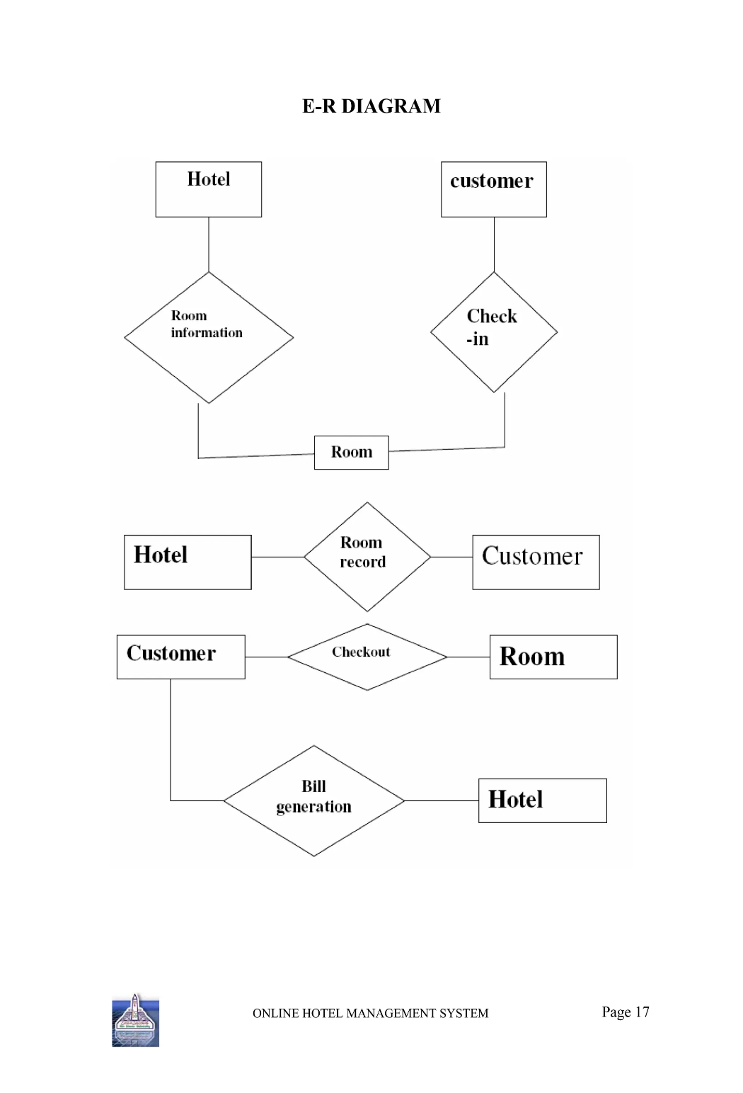

1. **Unified Modelling Language Diagrams**

The unified modelling language allows the software engineer to express an analysis model using the modelling notation that is governed by a set of syntactic semantic and pragmatic rules.

A UML system is represented using five different views that describe the system from distinctly different perspective. Each view is defined by a set of diagram, which is as follows**.**

* 1. User Model View :
     1. This view represents the system from the users perspective.
     2. The analysis representation describes a usage scenario from the end-users perspective.
  2. Structural model view :
     1. In this model the data and functionality are arrived from inside the system.
     2. This model view models the static structures**.**
  3. Behavioural Model View :
     1. It represents the dynamic of behavioural as parts of the system, depicting the interactions of collection between various structural elements described in the user model and structural model view**.**
  4. Implementation Model View :
     1. In this the structural and behavioural as parts of the system are represented as they are to be built.
  5. Environmental Model View :

a. In this the structural and behavioural aspects of the environment in which the system is to be implemented are represented.

1. **Testing**

Testing is the process of detecting errors. Testing performs a very critical role for quality assurance and for ensuring the reliability of software. The results of testing are used later on during maintenance also.

Psychology of Testing :

The aim of testing is often to demonstrate that a program works by showing that it has no errors. The basic purpose of testing phase is to detect the errors that may be present in the program. Hence one should not start testing with the intent of showing that a program works, but the intent should be to show that a program doesn’t work. Testing is the process of executing a program with the intent of finding errors.

Testing Objectives:

The main objective of testing is to uncover a host of errors, systematically and with minimum effort and time. Stating formally, we can say

* Testing is a process of executing a program with the intent of finding an error.
* A successful test is one that uncovers an as yet undiscovered error.
* A good test case is one that has a high probability of finding error, if it exists.
* The tests are inadequate to detect possibly present errors.
* The software more or less confirms to the quality and reliable standards.

Levels of Testing:

In order to uncover the errors present in different phases we have the concept of levels of testing. The basic levels of testing are as shown below…

Client Needs



Acceptance Testing



System Testing



Integration Testing

Requirements

Design

Code



Unit Testing

1. **Installation and project description**

The database as it is developed by oracle 11g can be installed only by using the export and import concepts.

Using core java and Servlets needs proper deployment as per general specifications developed the front end as it.

The project can be described by the screenshots in the project as follows

**The following screenshots appear when the admin login to the browser :**

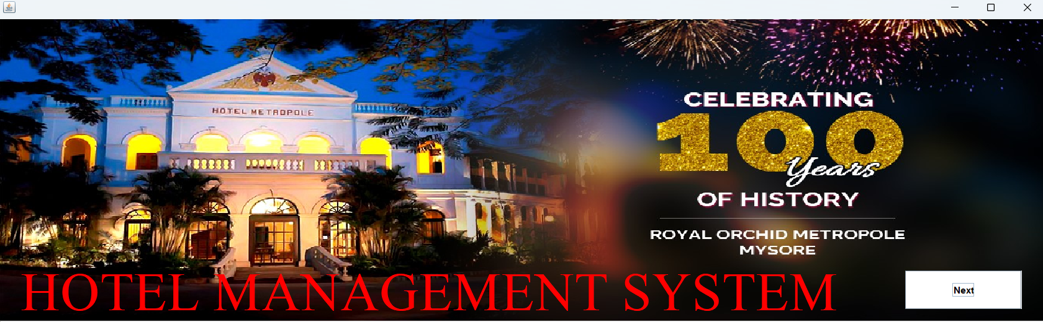

* LogIn Module

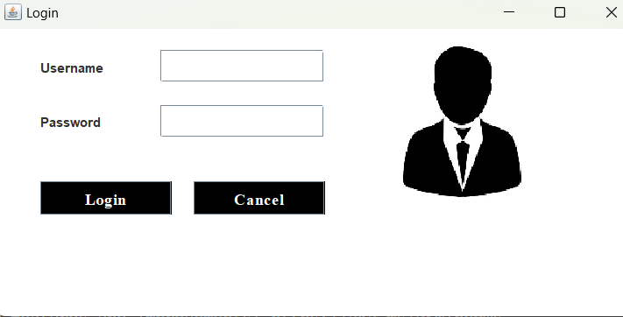

* 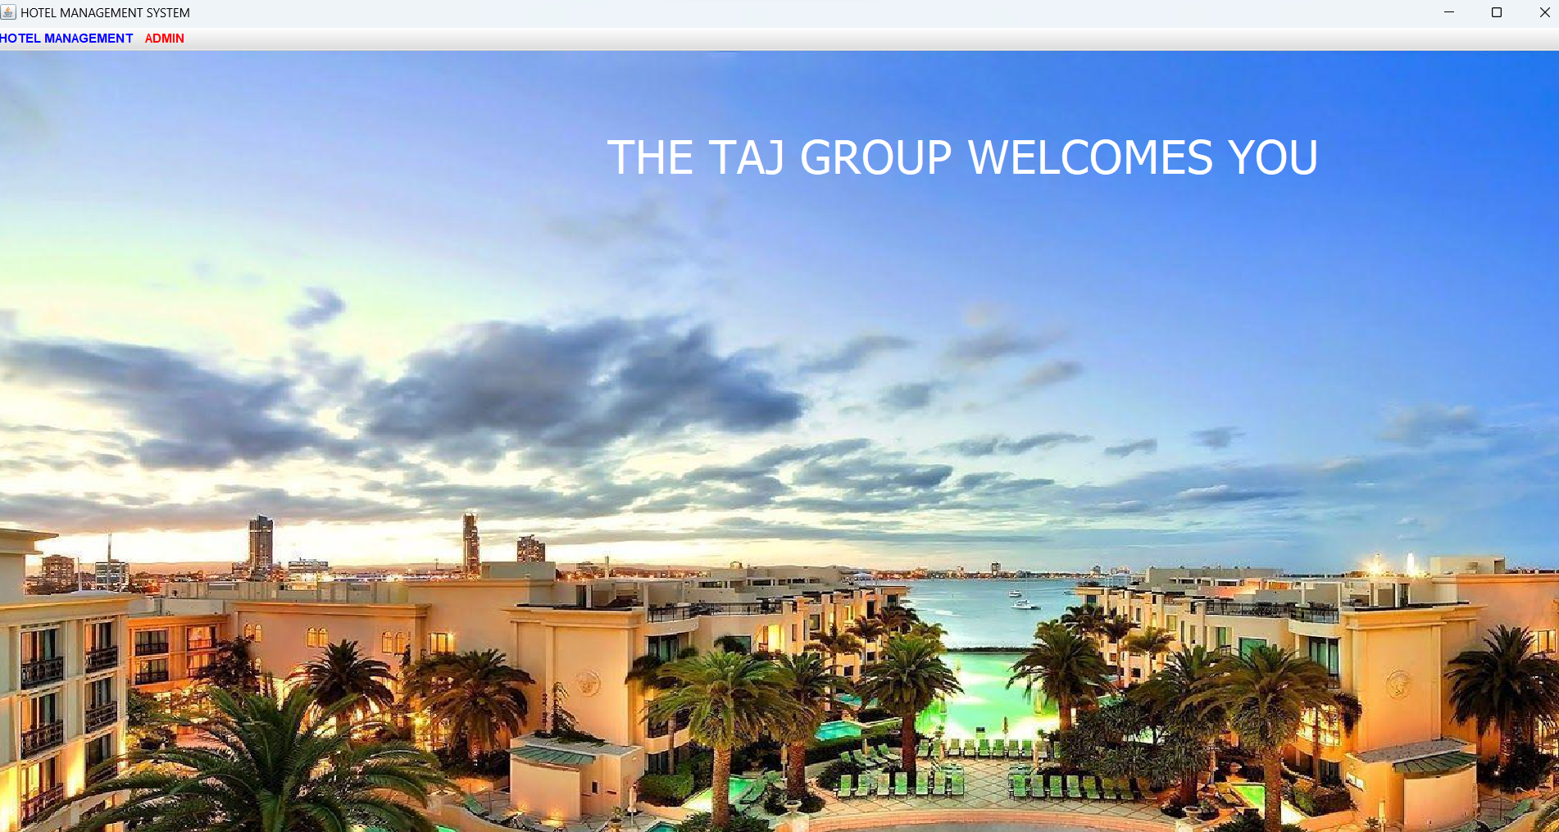Entering to Home Page Module.
* Go To Admin Module to add Employee, Add Room & Add Driveer.

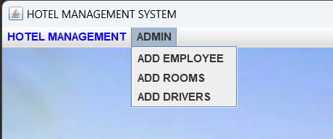

* In Add Employee module we can enter employee details, for different types off employee details.

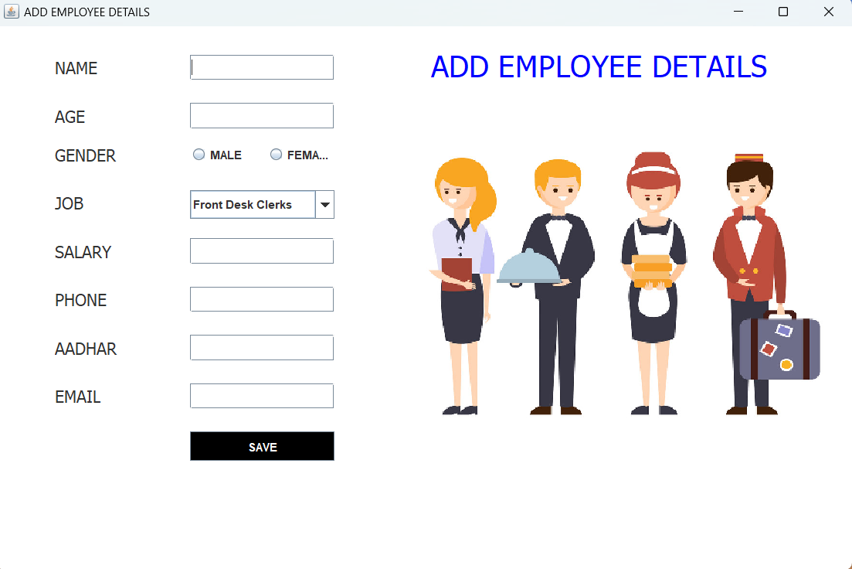

* In Add Romm module we can add different types of room and informations.

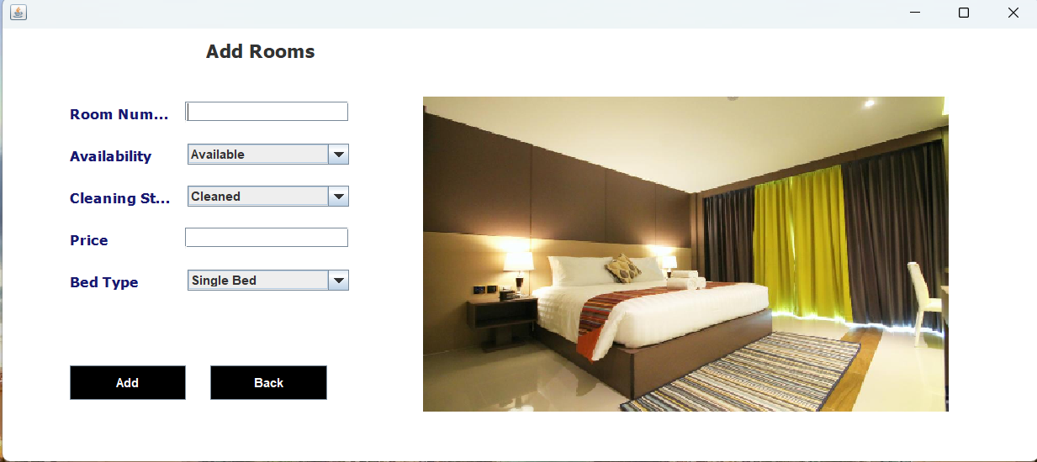

* In Add Driver module we can add different types of car types and modules & driver information.

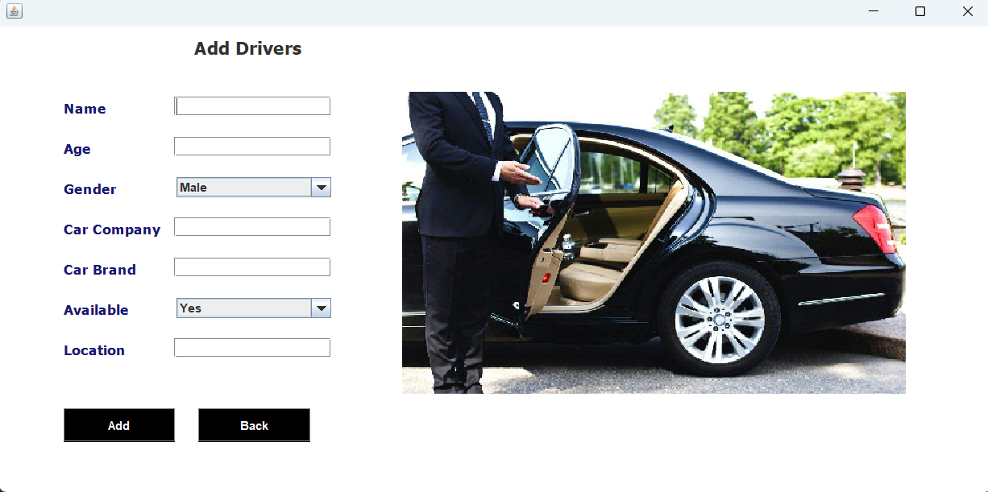

* Next Hotel Management module

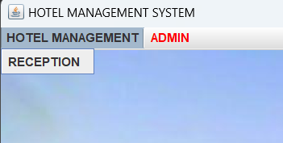

* In hotel management module we have Reception module in recption module we can view all type of information and edit it for our requirment.

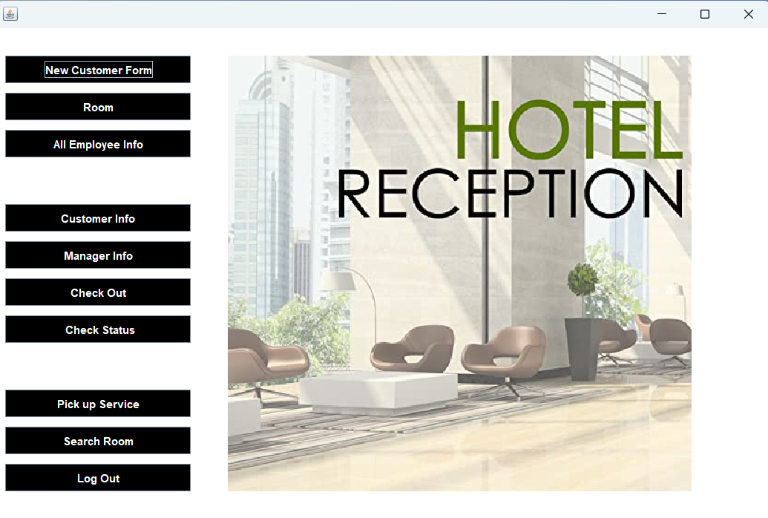

* Reception module
  + - 1. New Customer module in there we can add the customer information.

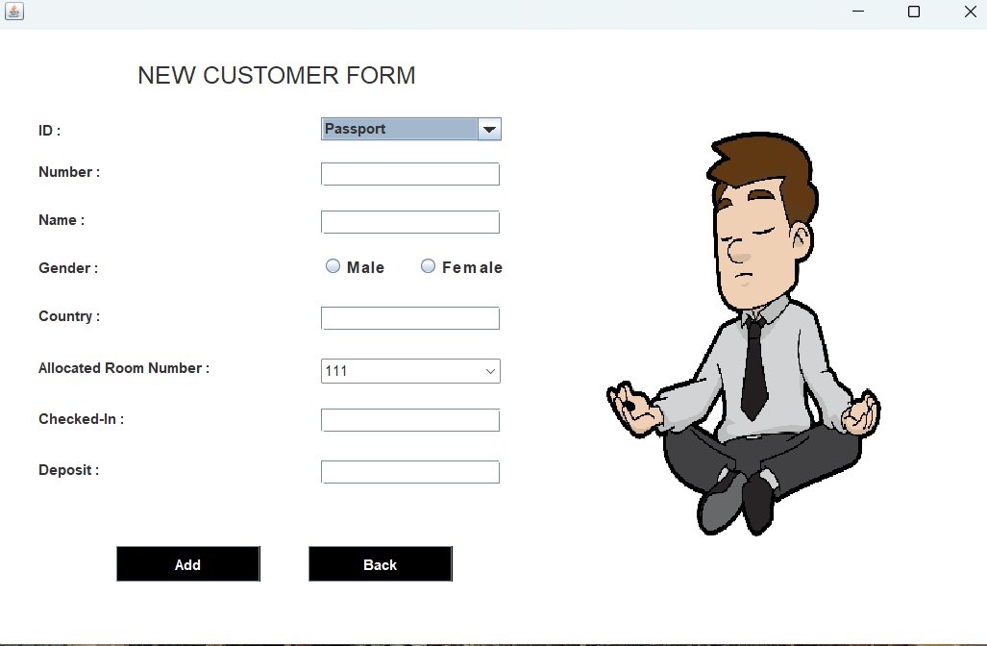

* + - 1. Room module we can add room types and numbes .



* + - 1. Employee information module we can view all information of employes.

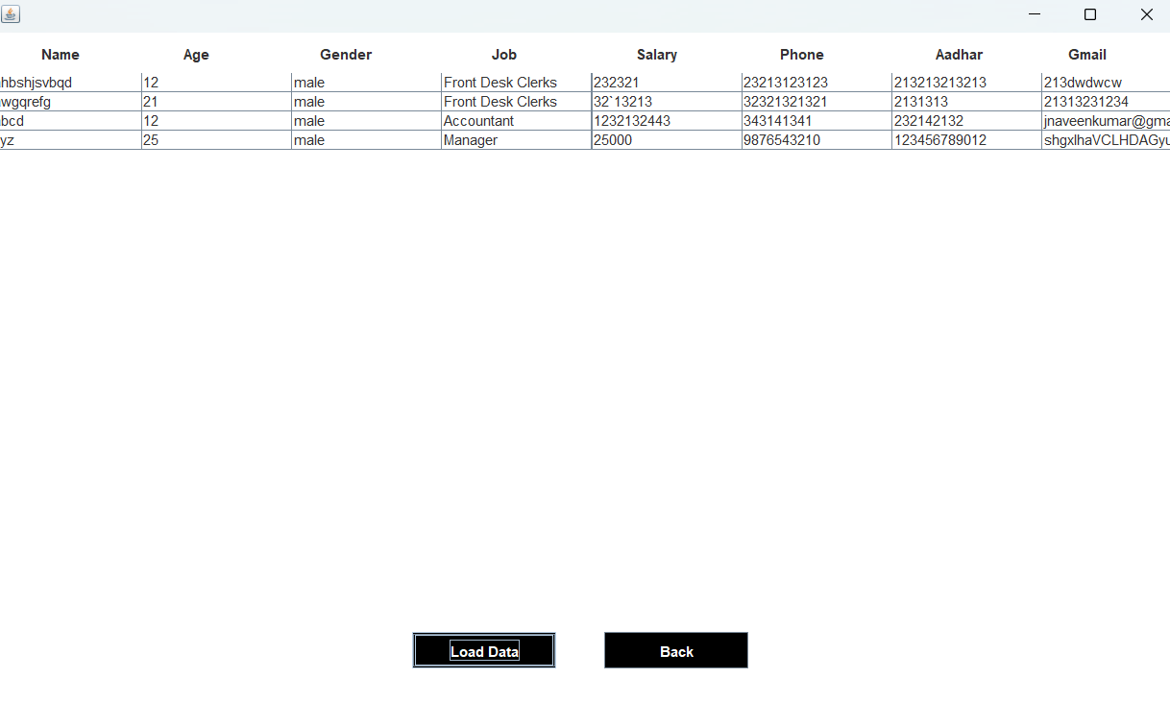

* + - 1. Customer information module we can view all information of Customers.

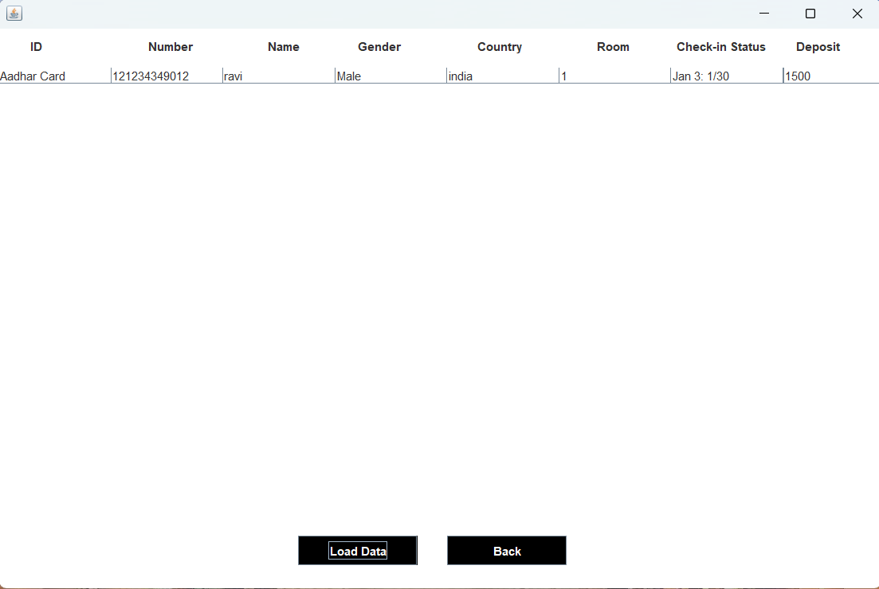

* + - 1. 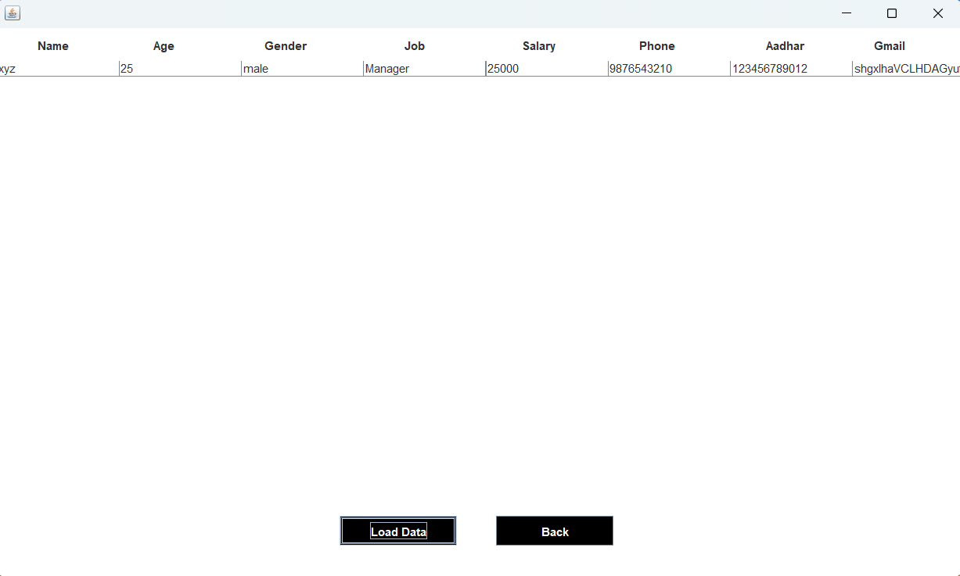Managere information module we can view all information of manager.
      2. Check out information module we can check out the Customer.

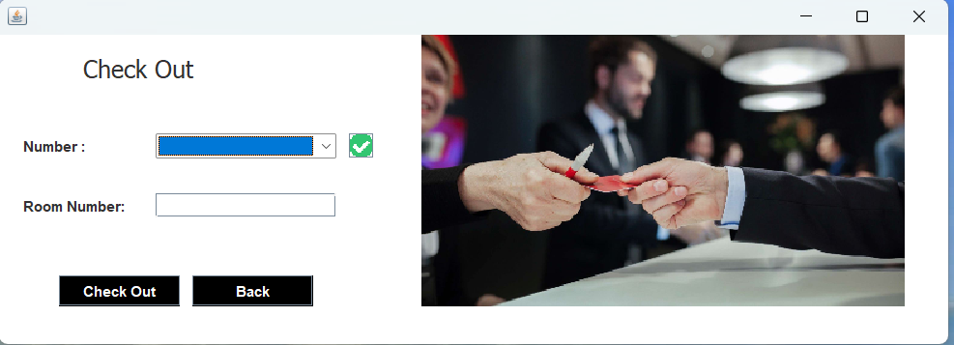

* + - 1. Check details module we can check all details of customers.

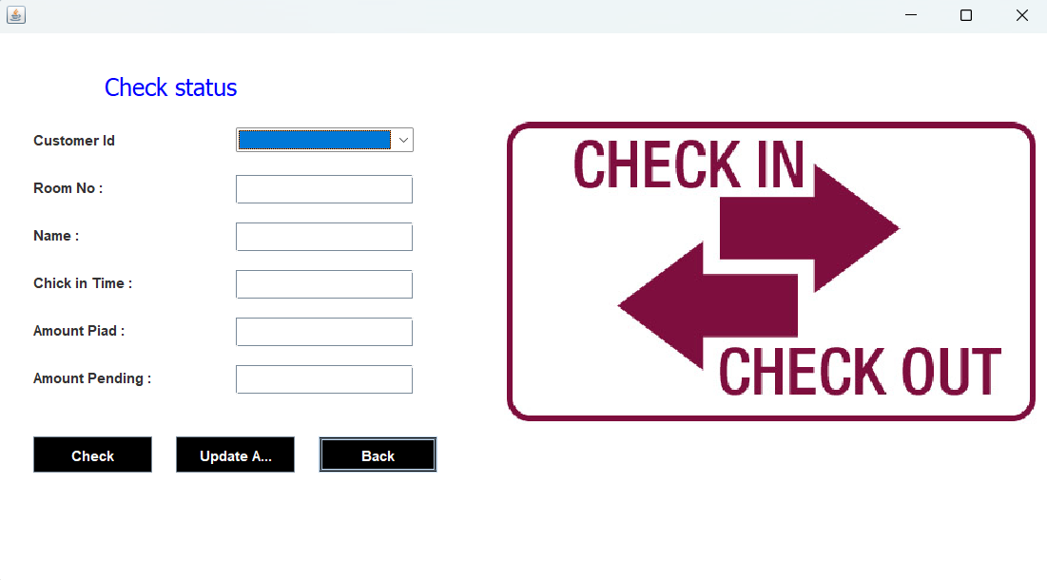

* + - 1. Pick-up-service module we can view all types of Drivers.

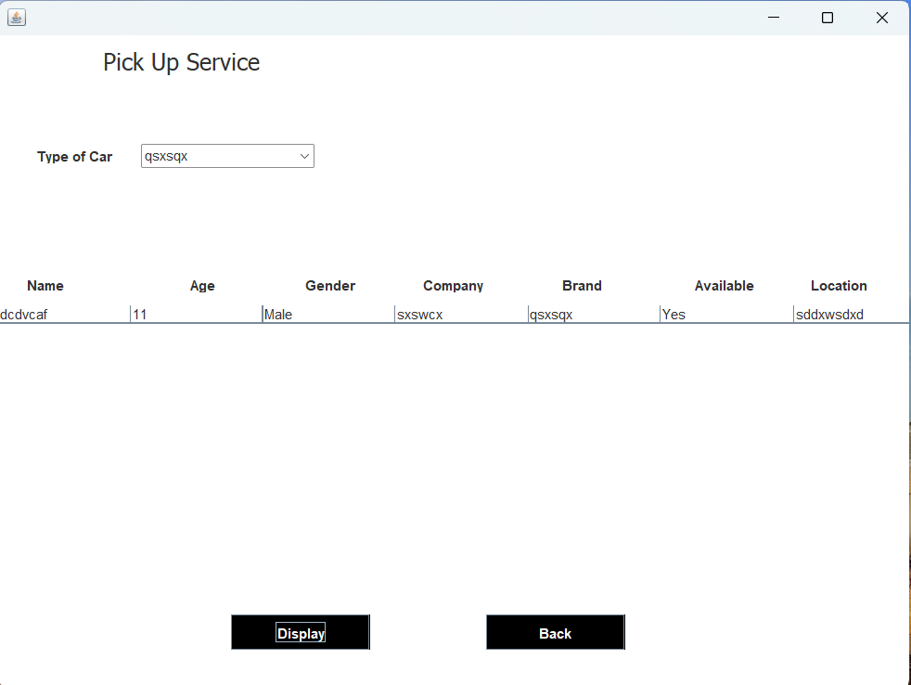

* + - 1. 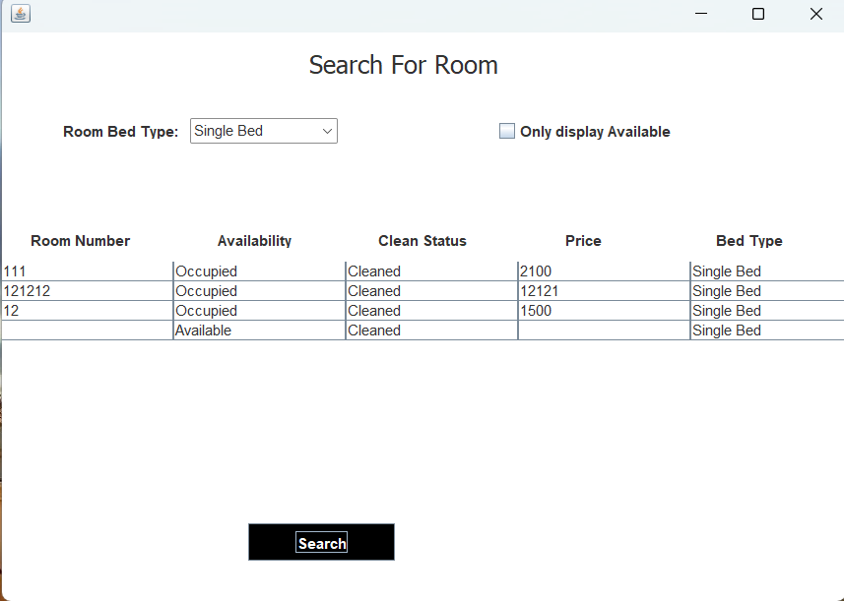Search-room module we can view all rooms details.
      2. Log-out module we can logout the admin.

1. **Conclusions And Recommendations**

The entire project has been developed and deployed as per the requirements stated by the user, it is found to be bug free as per the testing standards that are implemented. Any specification untraced errors will be concentrated in the coming versions, which are planned to be developed in near future.

The system at present does not take care of the money payment methods, as the consolidated constructs need SSL standards and are critically to be initiated in the first face, the application of the credit card transactions is applied as a developmental phase in the coming days. The system needs more elaborative technicality for its inception and evolution.

1. **References** :

MYSQL Programming [MySQL :: MySQL Documentation](https://dev.mysql.com/doc/)

JAVA Security, [Java Security Overview (oracle.com)](https://docs.oracle.com/en/java/javase/15/security/java-security-overview1.html)

J2EE Professional, [Home: Java Platform, Enterprise Edition (Java EE) 7 Release 7 (oracle.com)](https://docs.oracle.com/javaee/7/index.html)

Project From YouTube channel [(25) Code for Interview - YouTube](https://www.youtube.com/@codeforinterview).